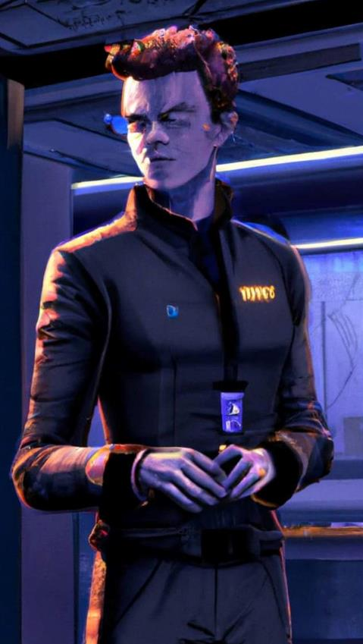

The Strange Cases of Rabbit Kyoami
There is been a few months since i wrote this and i wanted to tack on an addendum. one of the things i really liked about Outrage was the mission pack--actually all of the CB narrative mission packs are fun. so, i figured i'd make my own, drawing heavily on some inspiration for Lareon's (and IGL's) Mercs missions. so much so that i referenced some of them in case anyone wants to play something flavorful but less intricate.

Can't say i've really play tested these much, so they might be super jank. but hopefully they're also fun. the rules here aren't supposed to be hard and fast. if something doesn't work, skip it. if you think it should work differently, make the change. it's your table, afterall. just felt that after all the work i put into writing Rabbit's little adventure, it'd be nice to have a flavor of that on the table. happy to take any feedback, especially what doesn't work or isn't clear.

Fanfiction & Comic here:
https://forum.corvusbelli.com/threads/the-strange-cases-of-rabbit-kyoami.41265/

Svengali Closed Battle List (300 pts, 4.5 swc)
In terms of army selection, nothing really represents Svengali. to my mind, it's a little bit ALEPH meets Bakunin meets all the hive of scum and villainy troop types. with that in mind, i thought it might be fun to come up with a CBL like was around during Uprising. again, not really play tested and maybe not even optimized enough for the above missions, but I thought this sampling might give a little taste of Svengali's tools and agents.

Group 1 10 Regular Orders, 1 Lieutenant Order

- Post-Humans (1 Regular Order)
- PROXY MK. 2 (Hacker, Hacking Device) | Combi Rifle (25 pts, 0.5 swc)
- PROXY MK. 3 | AP Spitfire (23 pts, 1.5 swc)
- PROXY MK. 5 Forward Observer | Submachine Gun (+1B) (13 pts, 0.5 swc)
- Deva Functionary (1 Regular Order)
- DEVA Lieutenant | Combi Rifle (23 pts, 0 swc)
- DEVABOT | Heavy Flamethrower (4 pts, 0 swc)
- Puppetactica (1 Regular Order)
- PUPPET MASTERS | SMG (12 pts, 0 swc)
- PUPPETBOT Forward Observer | Boarding Shotgun (12 pts, 0 swc)
- PUPPETBOT (BS Attack [Shock]) | AP Marksman Rifle
- Karakuri Special Project (3 Regular Orders)
- KARAKURI | Mk 12 (45 pts, 0 swc)
- KARAKURI | MULTI Rifle (42 pts, 0 swc)
- KARAKURI | Heavy Shotgun (41 pts, 0 swc)
- Transductor Zonds (2 Regular Orders)
- TRANSDUCTOR ZOND | Flash Pulse (7 pts, 0 swc)
- TRANSDUCTOR ZOND | Flash Pulse (7 pts, 0 swc)
- Salyut Zonds (1 Regular Order)
- SALYUT (Hacker, EVO Hacking Device) | (15 pts, 0.5 swc)
- Vertigo Zonds (1 Regular Order)
- VERTIGO ZOND | Missile Launcher (17 pts, 1.5 swc)

01 Unmasking (ITS) / The Mole (Mercs) / Novvy Bangkok Bang

Escalation Level: 150 points

MISSION OBJECTIVES

MAIN OBJECTIVES
» Side A kills the Defector (3 Objective Points)
» Side B has the Defector in CivEvac state at the end of the game (3 Objective Points)
» Kill the enemy Elite Operator (1 Objective Point)
» To have scanned a High Value Target (1 Objective Point for each HVT, up to 3 Objective Points)
» To kill more specialists than the enemy (1 Objective Point)

CLASSIFIED
»There are no Classified Objectives.

FORCES AND DEPLOYMENT
SIDE A and SIDE B: Both players will deploy on opposite sides of the game table, in Deployment Zones whose size depends on the number of Army Points in the Army Lists.

SIDE A will be the player who goes first. SIDE B will be the player who goes second.

Exclusion Zone. The Exclusion Zone is the area covering 8 inches (4 inches in 150 point games) either side of the central line of the game table. Any Special Skill with the Airborne Deployment (AD) or Superior Deployment Labels cannot be used to deploy inside this area. It is not allowed to deploy in Silhouette contact with any HVT.

SCENARIO SPECIAL RULES

UPGRADED BIOMETRIC VISOR
Troopers with biometric visors may add WIP +6 to Defector rolls and can add or subtract 5 from the value of their Defector table roll.

In addition, if the opposing army controls any troopers that can deploy with the Impersonator skill, they must either choose to deploy with Imp-1 or Imp-2 state in the controlling player’s half of the board or forgo the use of impersonation skills during deployment to deploy in the opposing player’s half of the board using a normal WIP roll.

If the unit has a piece of equipment or skill that allows them to enter into impersonation states separate from the Infiltration skill, they may do so using orders during play.

ELITE OPERATOR
Each player will receive an Elite Operator according to whether they are Side A or Side B without applying Cost or SWC This Trooper does not count towards the Combat Group’s limit of ten Troopers or the Army List’s limit of 15 Troopers.

For the purposes of this scenario, the Elite Operator is considered a Specialist Troop. Side A gets a Black Bounty Assassin. Side B gets a Black Hand Exfiltrator.

Black Bounty Assassin
LI, Regular, Cube, MOV 6-2, CC 16, BS 12, PH 10, WIP 13, ARM 1, BTS 3, W 1, S 2, Boarding Shotgun, Pistol, Explosive CCW, Booty (ReRoll), Counts as a (Bounty Hunter) for Fireteam Composition, Stealth

Black Hand Exfiltrator
LI, regular, Cube, move 4-4, CC 13, BS 11, PH 10, WIP 14, ARM 0, BTS 3, W 1, S 2, SMG, Nanopulser (+1B) E/M Mines, Pistol, Para CCW (-6), Biometric Visor, Discover (+3,) Immunity (Shock), Sixth Sense, Bioimmunity, CC Attack (-3), Mimetism (-3)

DEFECTOR
Players will deploy four High Value Targets (HVTs) within the Exclusion Zone, applying the conventional rules, but only one of them can be the Defector. In order to identify the Defector, a player's Specialist Troopers must make base to base contact with an HVT and pass a modified WIP -3 roll. If the WIP roll is successful, players will make a second roll based on the table below. All the HVTs have an HVT Profile (Neutral Civilian) until they are Revealed as a Defector, or as a Target Decoy. Bonuses to this roll from other skills and equipment do not stack and a player must take the highest available bonus. Each Defector result can only be rolled once. If a duplicate result is rolled, reroll until a new result is achieved.

Roll Result
- 1-5 HVT is the Defector, remove other HVT models
- 6-10 HVT is a Target Decoy (Black market merchant). Remove this model from play and treat it as a panopy per the special skill and table below. Accessing the Panopoly requires the use of an additional short skill.
- 11-15 HVT is a Target Decoy. Remove this model from play.
- 16-20 HVT is a Target Decoy (Brawler). Remove this model from play and replace it with an S2 trooper model. Treat this as a Brawler armed with a Rifle + Light Shotgun profile. The trooper is treated as if it has the Total Reaction skill and a 360 visor. It will react to any active player trooper in its line of fire (LoF) and/or zone of control (ZoC) and the reactive player will control its actions without adding it to their Army List. This model cannot move from its position even if it achieves a successful dodge roll. It is not treated as an allied trooper for either army.

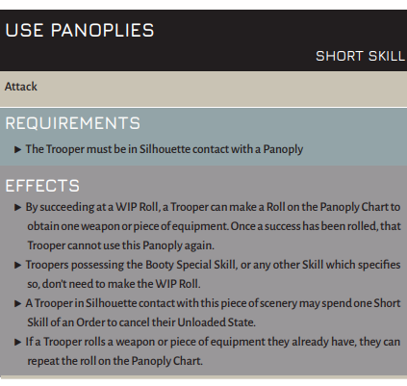
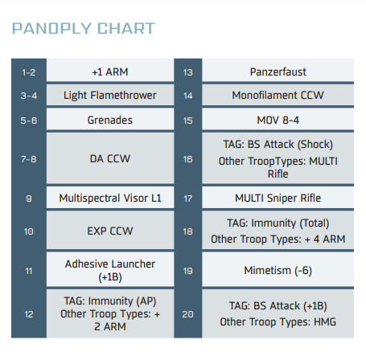

SPECIALIST TROOPS
For the purposes of this scenario, only Hackers, Doctors, Engineers, Forward Observers, Paramedics, and Troopers possessing the Chain of Command or the Specialist Operative Special Skill are considered Specialist Troops.

Hackers, Doctors, and Engineers cannot make use of Repeaters or Peripheral (Servant) Models to perform tasks reserved for Specialist Troops

DOCTOR BONUS
Troopers possessing the Doctor Special Skill have a MOD of +3 to the WIP Rolls necessary to identify the Defector.

HACKER BONUS
Troopers possessing the Hacker Special Skill have a MOD of +3 to the WIP Rolls necessary to identify the Defector.

NARRATIVE MODE
This scenario can be played in Narrative Mode, reflecting some of the events of the story above.

Narrative Mode. Scenario Special Rules

Side A. In Narrative Mode, Side A will always be one of the following armies: Druze Bayram Security, Ikari Company, Spiral Corps, Dahshat Company, White Company, Hassassin Bahram, Operations Subsection of the SSS, Shasvastii Expeditionary Force.

Side A can add the Black Bounty Assassin without applying Cost or SWC. This Trooper does not count towards the Combat Group’s limit of ten Troopers.

Side B. In Narrative Mode, Side B will always be a Nomads force or Sectorial, Foreign Company, or the StarCo. Free Company of the Stars.

Side B can add the Black Hand Exfiltrator without applying Cost or SWC. This Trooper does not count towards the Combat Group’s limit of ten Troopers.

KILLING
Troopers are considered Killed by the adversary when they enter Dead State, or they are in a Null State at the end of the game. Troopers that have not been deployed on the game table, as a Model or Marker, at the end of the game will be considered to be Killed by the adversary.

END OF THE MISSION
This scenario has a limited time frame, so it will automatically finish at the end of the third Game Round.

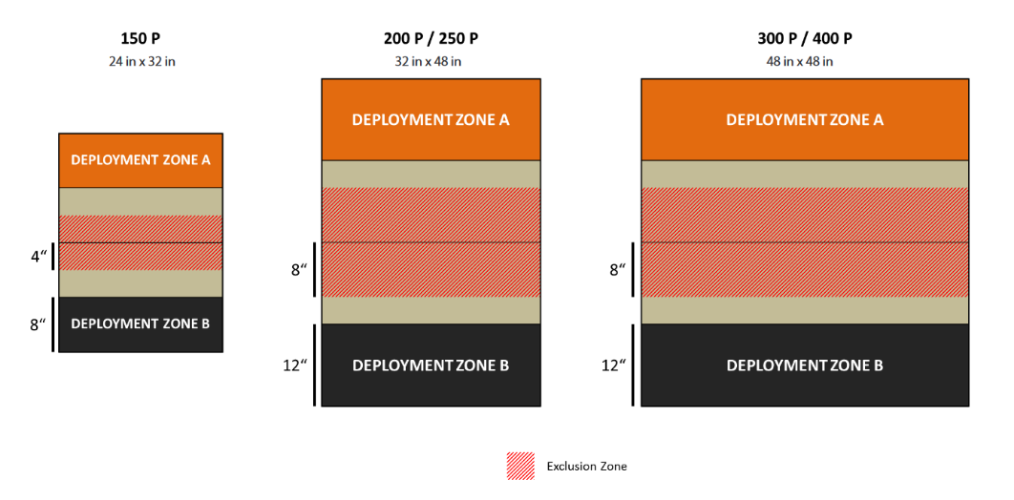

02 Frontline (ITS) / Backstab (Mercs) / VaudeVille Shootout

Escalation Level: 200pts

MISSION OBJECTIVES

MAIN OBJECTIVES
»At the end of each Game Round, Dominate the Quadrant with the Cat Civilian (2 Objective Point).
»At the end of each Game Round, Dominate the Quadrant with the Mediocre Detective Civilian (1 Objective Point).

CLASSIFIED
»Each player has 1 Classified Objective (1 Objective Point).

FORCES AND DEPLOYMENT
SIDE A and SIDE B: Both players will deploy on opposite sides of the game table, in Deployment Zones whose size depends on the number of Army Points in the Army Lists.

SIDE A will be the player who goes first. SIDE B will be the player who goes second.

Confused Deployment. Any Trooper deploying outside their Deployment Zone must make a PH Roll with a -3 MOD. This Roll replaces any PH or WIP Roll that the Trooper would normally make to deploy. Any MODs from Special Skills, pieces of Equipment, or rules that apply any Roll to deploy will be added to this Roll.

For example a Trooper with Infiltration must make a Roll if they deploy outside their Deployment Zone. There will be a -3 MOD to deploy in their half of the game table, or a -6 MOD to deploy in the opponent’s half of the game table.

If the player fails the Roll, the Trooper will be deployed anywhere in their Deployment Zone. Additionally, after failing the Roll, the user loses the option to deploy in a Marker State or Hidden Deployment State and is always deployed as a Model. Any Deployable Weapons and Equipment deployed alongside them are removed from the game table

SCENARIO SPECIAL RULES

CIVILIANS
There are a total of two Civilians on the game table, represented by High Value Target (HVT) models.

The first Civilian model should be represented by an S1 model or remote, such as a Taigha, Gaki, Palbot, etc., or the Pig tokens from the Fat Yuan Yuan mission set, or some sort of cat model on a 25 milimeter base. This will represent the Cat Civilian.

The second Civilian model should be represented by an S2 HVT model, such as Colonel Voronin, or other HVT model. This will represent the Mediocre Detective Civilian. Civilians will be deployed at the beginning of each round according to the Yakety Sax rule.

YAKETY SAX
At the beginning of each game round, both players will roll a single D20 and deploy a civilian according to the table below. Player A will deploy the Cat Civilian model. Player B will deploy the Mediocre Detective Civilian model.

No result may be used more than once. If a result is rolled a second time, reroll the second result until a different result is obtained.

A Civilian model may deployed anywhere in the quadrant but must be deployed fully within the quadrant.

Roll Result
- 1-5 Quadrant 1 (Player A right quadrant)
- 6-10 Quadrant 2 (Player A left quadrant)
- 11-15 Quadrant 3 (Player B right quadrant)
- 16-20 Quadrant 4 (Player B left quadrant)

QUADRANTS (ZO)
At the end of each Game Round, but not before, the table area outside the deployment zones is divided into four areas based on the horizontal and vertical center lines of the map. In 150 point games, these Sectors are 8 inches deep and 12 inches wide. In 200/250 point games, these Sectors are 12 inches deep and 16 inches wide. In 300/400 point games, these Sectors are 12 inches deep and 24 inches wide. Each player then checks how many Quadrants they are dominating and counts their Objective Points.

Once quadrants are determined, players will place Player A and Player B tokens in each of the quadrants adjacent to their Deployment Zones. Quadrants will be numbered sequentially starting with Player A’s right hand quadrant, moving clockwise (i.e. Player A right quadrant is quadrant 1, player A left quadrant is quadrant 2, Player B right quadrant is quadrant 3, player B left quadrant is quadrant 4.(See diagram below).

In this scenario each Quadrant is a Zone of Operations (ZO).

DOMINATE ZO
A Zone of Operations (ZO) is Dominated by a player if they have more Victory Points than the adversary inside the area. Only Troopers represented by Models or Markers (Camouflaged, Shasvastii-Embryo, Seed-Embryo, etc.) count, as well as Proxies and Peripheral Troops. Troops in a Null State do not count. Tokens representing weapons or pieces of equipment (like Mines or Deployable Repeaters), fake Holoechoes, and any Token that does not represent a Trooper does not count either. A Trooper is inside a Zone of Operations when more than half the Trooper’s base is inside that ZO.

SHASVASTII
Troopers possessing the Shasvastii Special Skill that are inside a Zone of Operations count while they are in the Shasvastii-Embryo State or any non-Null State.

BAGGAGE
Troopers possessing the Baggage piece of Equipment that are inside a Zone of Operations and in a non-Null State provide an additional 20 Victory Points for Dominating the ZO.

INTELCOM CARD (SUPPORT AND CONTROL)
Before the beginning of the game, but after choosing the Classified Objective, the player must inform to their adversary if that card will be their Classified Objective or their INTELCOM Card.

Each player rolls a die and the one who gets the highest score must be the first who announces their decision to their adversary. The content of the card, whether the mission or the card numeric value, is Private Information, no matter which use the player has chosen for it.

At the end of the last Game Round, when the players count up their points and in Initiative order, the player can use their INTELCOM Card in Support and Control Mode.

Support and Control Mode: The player can add the value of the Support and Control Card to their Victory Points in the Zone of Operations (ZO) of their choice. The player must have at least one Trooper inside that ZO, in a non-Null State

ELITE OPERATOR
Each player will receive an Elite Operator according to whether they are Side A or Side B without applying Cost or SWC This Trooper does not count towards the Combat Group’s limit of ten Troopers or the Army List’s limit of 15 Troopers.

For the purposes of this scenario, the Elite Operator is considered a Specialist Troop. Side A gets a Svengali Node Trooper Side B gets a Moderator Sargeant. When scoring ZO, each Elite Operator will be scored as if having the baggage rule.

Svengali Node Trooper Mk. 1 20 VP
MI, Regular, Cube, MOV 4-4, CC 14, BS 13, PH 11, WIP 15, ARM 3, BTS 3, STR 1, S 2, Submachine Gun (+1B), Pistol, Viral CCW, G: Jumper, Forward Deployment (+4”), No Wound Incapacitation, Stealth

Note: When fielding an Army with access to G: Jumper, the Svengali Node Trooper generates a separate regular order and does not count towards the limits on Post Humans.

Moderator Sargeant 20 VP
LI, Regular, Cube, MOV 4-4, CC 18, BS 11, PH 10, WIP 13, ARM 0, BTS 3, W 1, S 2, Heavy Machine Gun, Pistol, Para CCW (-6), Immunity (Shock), Counts as a (Moderator) for Fireteam Composition

SPECIALIST TROOPS
For the purposes of this scenario, only Hackers, Doctors, Engineers, Forward Observers, Paramedics, and Troopers possessing the Chain of Command or the Specialist Operative Special Skill are considered Specialist Troops.

Hackers, Doctors, and Engineers cannot make use of Repeaters or Peripheral (Servant) Models to perform tasks reserved for Specialist Troops

NARRATIVE MODE
This scenario can be played in Narrative Mode, reflecting some of the events of the story above.

Narrative Mode. Scenario Special Rules

Side A. In Narrative Mode, Side A will always be one of the following armies: Druze Bayram Security, Ikari Company, Dahshat Company, Operations Subsection of the SSS, Svengali Closed Battle List.

Side A can add the Svengali Node Trooper without applying Cost or SWC. This Trooper does not count towards the Combat Group’s limit of ten Troopers.

Side B. In Narrative Mode, Side B will always be a Bakunin Jurisdictional Command force.

Side B can add the Moderator Sargeant without applying Cost or SWC. This Trooper does not count towards the Combat Group’s limit of ten Troopers.

END OF THE MISSION
This scenario has a limited time frame, so it will automatically finish at the end of the third Game Round.

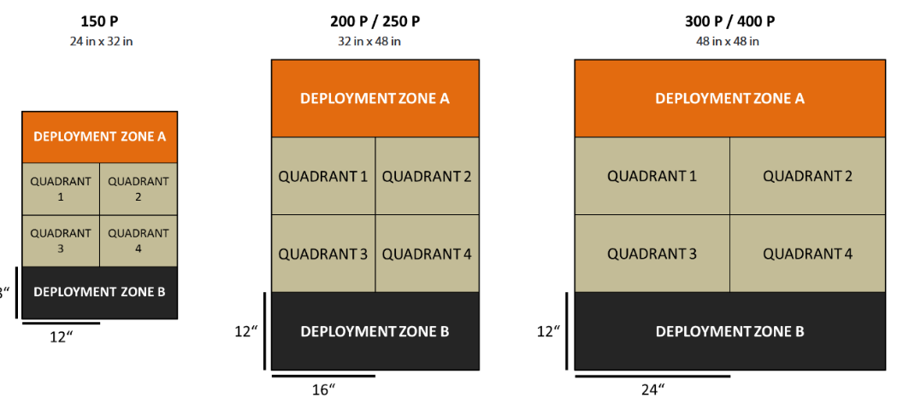

03 Rescue (ITS) / Escape with the shuttle (Mercs) / The Arc of the Universe Bends Towards Chaos

Escalation Value: 300pts

MISSION OBJECTIVES

MAIN OBJECTIVES
»At the end of Game Round, Have the Cat HVT in CivEvac State (3 Objective Point).
»At the end of Game Round, Have the Mediocre Detective in CivEvac State (1 Objective Point).
» Have the same number of Civilians in CivEvac State as the adversary at the end of the game (1 Objective Point, only if the player has at least 1 Civilian in CivEvac State).
» Have more Civilians in CivEvac State than the adversary at the end of the game (2 Objective Points).
» Kill the enemy Elite Operator (2 Objective Point)
» To kill more specialists than the enemy (1 Objective Point)

CLASSIFIED
»Each player has 1 Classified Objective (1 Objective Point).

FORCES AND DEPLOYMENT
SIDE A and SIDE B: Both players will deploy on opposite sides of the game table, in Deployment Zones whose size depends on the number of Army Points in the Army Lists.

SIDE A will be the player who goes first. SIDE B will be the player who goes second.

Exclusion Zone. The Exclusion Zone is the area covering 8 inches (4 inches in 150 point games) either side of the central line of the game table. Any Special Skill with the Airborne Deployment (AD) or Superior Deployment Labels cannot be used to deploy inside this area.

It is not allowed to deploy in Silhouette contact with a Civilian.

SCENARIO SPECIAL RULES

CIVILIANS
There are a total of two Civilians on the game table, represented by High Value Target (HVT) models.

The first Civilian model should be represented by an S1 model or remote, such as a Taigha, Gaki, Palbot, etc., or the Pig tokens from the Fat Yuan Yuan mission set, or some sort of cat model on a 25 millimeter base. This will represent the Cat Civilian. Player A will deploy the Cat Civilian at the start of the game round according to normal rules in a quadrant determined by Yakety Sax.

The second Civilian model should be represented by an S2 HVT model, such as Colonel Voronin, or other HVT model. This will represent the Mediocre Detective Civilian. Player B will deploy the Mediocre Detective Civilian at the start of the game round according to normal rules in a quadrant determined by Yckety Sax.

Players will deploy the civilians in the Exclusion Zone according to normal rules. Player A will deploy the Cat Civilian Model. Player B will deploy the Mediocre Detective Civilian model.

Any player can Synchronize either or both Civilians.

In this scenario, Specialist Troops can have only one Civilian in CivEvac State at the same time. Only Specialist Troops can Synchronize Civilians.

Civilians will be deployed at the beginning of each round according to the Yakety Sax rule. If a Civilian model is in CivEvac State at the end of Game Round, do not apply deployment or Yakety Sax rules (in plain words, once a Civilian is ‘captured’ it should remain with the synced Specialist Troop)

INTERLOPERS
There are a total of two Interlopers on the game table, represented by Camo (-3) tokens.

The first Interloper token will represent an S2 model, such as a Tariqa HVT or similar model, which should replace the token if it is revealed by a successful Discover action or ARO. This will be the Rogue Zelda Interloper and will have the following profile:

Rogue Zelda
SK, Regular, Cube, MOV 4-4, CC 23, BS 11, PH 13, WIP 13, ARM 0, BTS 3, W 1, S 2, Nanopulser, Smoke Grenades, Pistol, DA CCW, Martial Arts L3, CC Attack (-3), CC Attack (Viral), Camouflage, Dodge (+1”), Dodge (+3), Mimetism (-3), Stealth, Terrain (Total), No Wound Incapacitation, Immunity (Shock)

The Rogue Zelda will be deployed by Player B at the start of the game round in a quadrant determined by Yakety Sax according to normal rules.

The Rogue Zelda will be controlled by the reactive player during each player turn and may declare AROs as normal. It is not considered an allied troop.

The second Interloper Token will represent a Rogue Repeater. This repeater may declare Carbonite (+3 DAM) against any model activating or ending an activation within its Zone of Control (ZoC).

The Rogue Repeater will be controlled by the reactive player during each player turn and may only declare the Carbonite program in ARO. It is not considered part of the either player’s Hacking Area.

If either the Rogue Zelda or Rogue Repeater are in a null state or destroyed at the end of game round, do not deploy new Interloper Tokens per the Yakety Sax rule. Interloper Tokens must be deployed within their quadrant but do not need to be deployed in the Exclusion Zone.

YAKETY SAX
At the beginning of each game round, both players will roll a two D20s and deploy both a Civilian model and an Interloper token according to the table below. Player A will deploy the Cat Civilian model and Interloper token for the Rogue Repeater. Player B will deploy the Mediocre Detective Civilian model and the Interloper Token for the Rogue Zelda.

Players may assign results to the Civilian model and Interloper token after the dice are rolled (i.e. the Player may choose which of their D20 results applies to their Civilian model and apply the other to the Interloper token).

No result may be used more than once. If a result is rolled a second time, reroll the second result until a different result is obtained.

All Civilian models and interloper tokens must be deployed fully within the quadrant. Civilian models must be deployed within the Exclusion Zone.

Roll Result
- 1-5 Quadrant 1 (Player A right quadrant)
- 6-10 Quadrant 2 (Player A left quadrant)
- 11-15 Quadrant 3 (Player B right quadrant)
- 16-20 Quadrant 4 (Player B left quadrant)

As in the Civilian and Interloper rules, if a Civilian model is in the CivEvac state at end of game round or the model/piece of equipment represented by the Interloper token removed from play by the end of game round, do not apply Yakety Sax to redeploy these models. (In plain wording, if the Civilian is captured by a specialist, or the Rogue Zelda in a null state, or the Rogue Repeater destroyed, don’t undo the current game state for that Civilian or Rogue Zelda or Rogue Repeater. It’s dead or caught. Play on. These rules are convoluted enough.).

QUADRANTS (ZO)
At the end of each Game Round, but not before, the table area outside the deployment zones is divided into four areas based on the horizontal and vertical center lines of the map. In 150 point games, these Sectors are 8 inches deep and 12 inches wide. In 200/250 point games, these Sectors are 12 inches deep and 16 inches wide. In 300/400 point games, these Sectors are 12 inches deep and 24 inches wide. Each player then checks how many Quadrants they are dominating and counts their Objective Points.

Once quadrants are determined, players will place Player A and Player B tokens in each of the quadrants adjacent to their Deployment Zones. Quadrants will be numbered sequentially starting with Player A’s right hand quadrant, moving clockwise (i.e. Player A right quadrant is quadrant 1, player A left quadrant is quadrant 2, Player B right quadrant is quadrant 3, player B left quadrant is quadrant 4. See diagram below).

In this scenario each Quadrant is a Zone of Operations (ZO).

ELITE OPERATOR
Each player will receive an Elite Operator according to whether they are Side A or Side B without applying Cost or SWC This Trooper does not count towards the Combat Group’s limit of ten Troopers or the Army List’s limit of 15 Troopers. For the purposes of this scenario, the Elite Operator is considered a Specialist Troop. Side A gets a Svengali Node Trooper Side B gets a Moderator Sargeant.

Svengali Node Trooper Mk. 2 (25+1spec ops-4 mmr+1 bs skill+2 NCO)
MI, Regular, Cube, MOV 6-2, CC 13, BS 13, PH 14, WIP 15, ARM 5, BTS 6, STR 2, S 2, MULTI Marksman Rifle, Pistol, CCW, G: Jumper, BS Attack (Viral), Immunity (Shock), NCO

Note: When fielding an Army with access to G: Jumper, the Svengali Node Trooper generates a separate regular order and does not count towards the limits on Post-Humans.

Moderator Sargeant SWAST Trained 30 VP (9+1 spec ops+5 bs + 8 hmg +10 armor+2 ph)
LI, Regular, Cube, MOV 4-4, CC 18, BS 11, PH 10, WIP 13, ARM 3, BTS 3, W 1, S 2, Heavy Machine Gun, Pistol, Para CCW (-6), Immunity (Shock), Counts as a (Moderator) for Fireteam Composition

SPECIALIST TROOPS
For the purposes of this scenario, only Hackers, Doctors, Engineers, Forward Observers, Paramedics, and Troopers possessing the Chain of Command or the Specialist Operative Special Skill are considered Specialist Troops.

Hackers, Doctors, and Engineers cannot make use of Repeaters or Peripheral (Servant) Models to perform tasks reserved for Specialist Troops

NARRATIVE MODE
This scenario can be played in Narrative Mode, reflecting some of the events of the story above.

Narrative Mode. Scenario Special Rules

Side A. In Narrative Mode, Side A will always be one of the following armies: Druze Bayram Security, Ikari Company, Dahshat Company, Operations Subsection of the SSS, Svengali Closed Battle List.

Side A can add the Svengali Node Trooper without applying Cost or SWC. This Trooper does not count towards the Combat Group’s limit of ten Troopers.

Side B. In Narrative Mode, Side B will always be a Bakunin Jurisdictional Command force.

Side B can add the Moderator Sargeant without applying Cost or SWC. This Trooper does not count towards the Combat Group’s limit of ten Troopers.

KILLING
Troopers are considered Killed by the adversary when they enter Dead State, or they are in a Null State at the end of the game. Troopers that have not been deployed on the game table, as a Model or Marker, at the end of the game will be considered to be Killed by the adversary.

END OF THE MISSION
This scenario has a limited time frame, so it will automatically finish at the end of the third Game Round.

