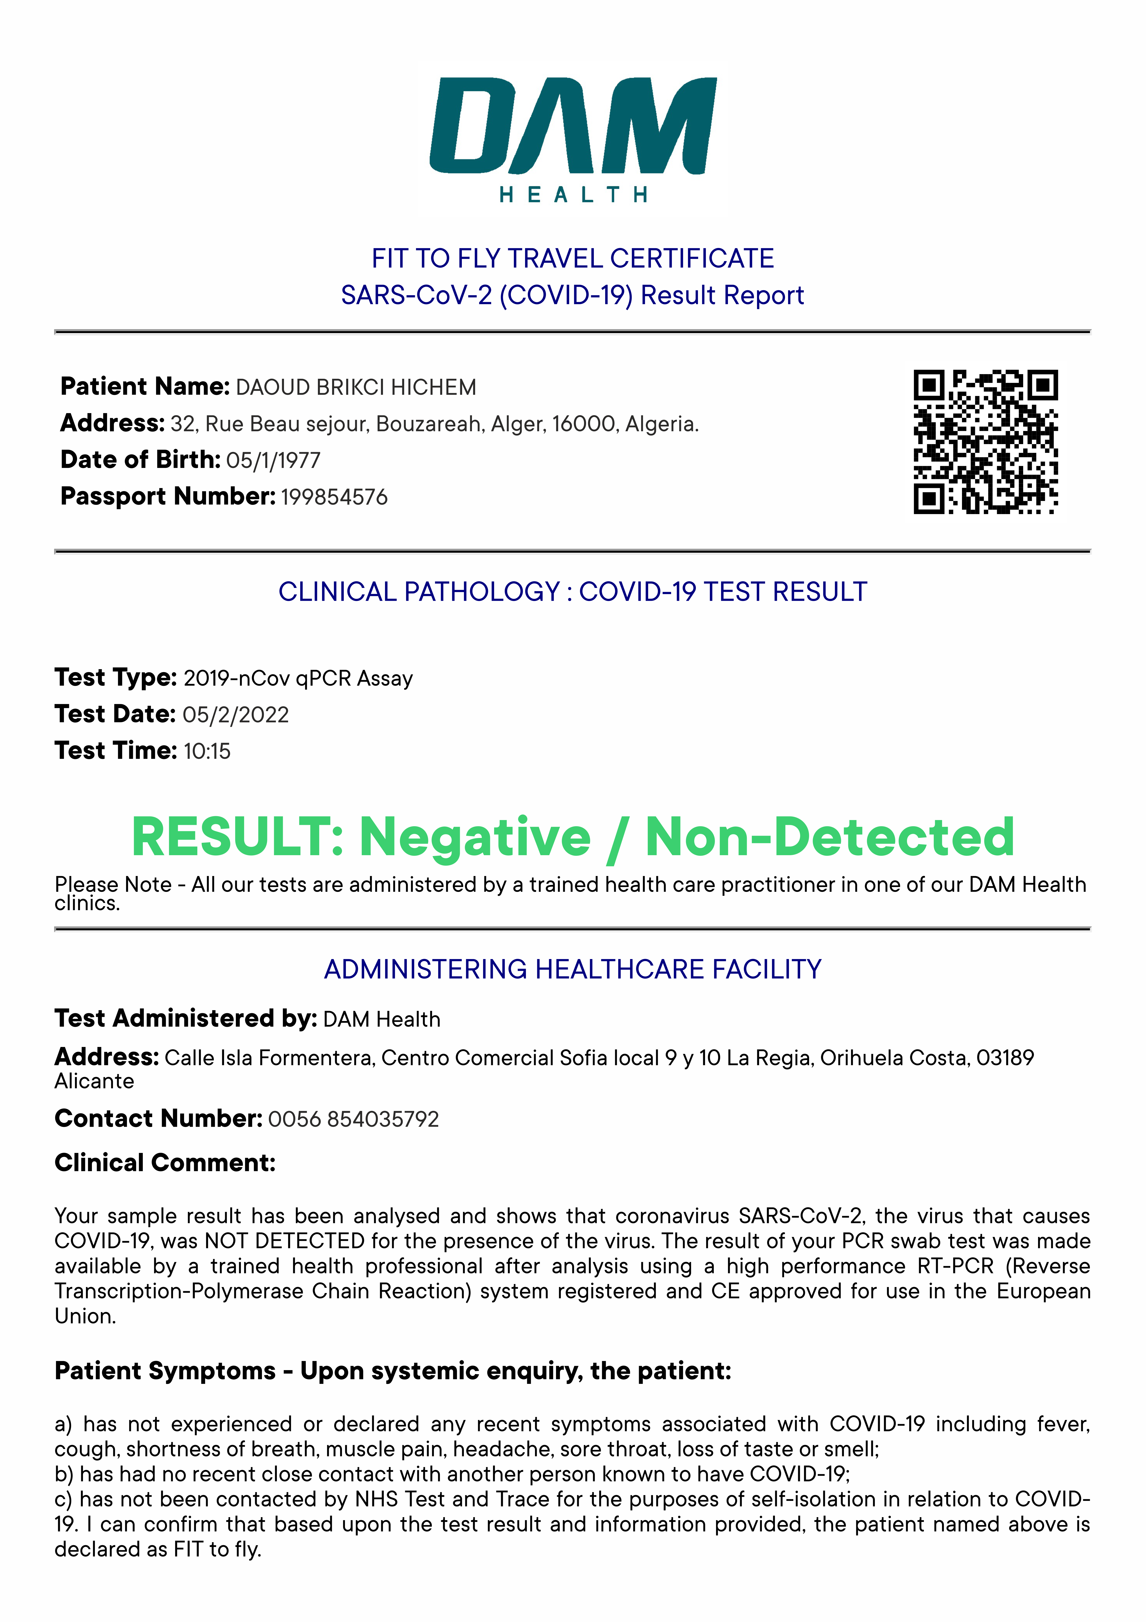

Dr. José María Gómez-Reino Sanchis

Validation: If required, test validation can be obtained by emailing orihuelacosta@damhealth.es quoting the Test/Date and Serial Number

