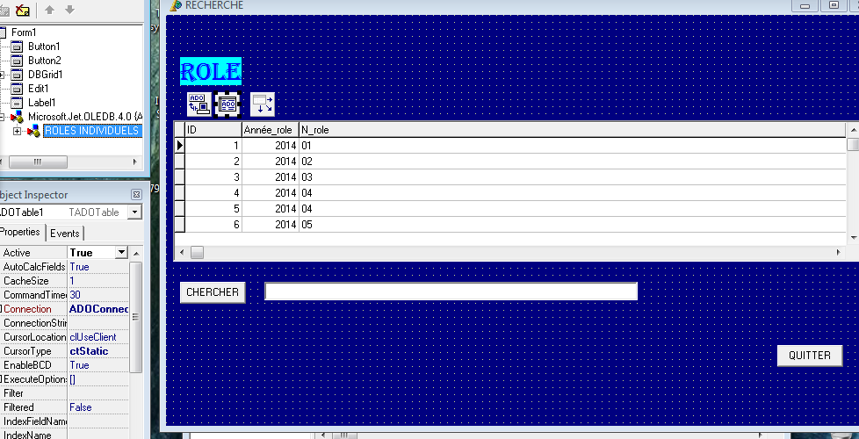

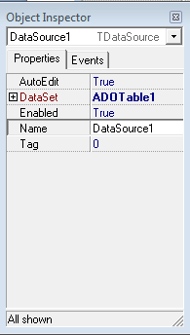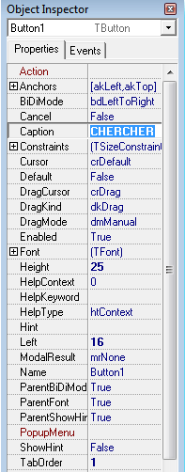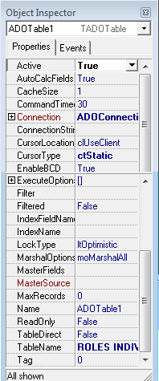

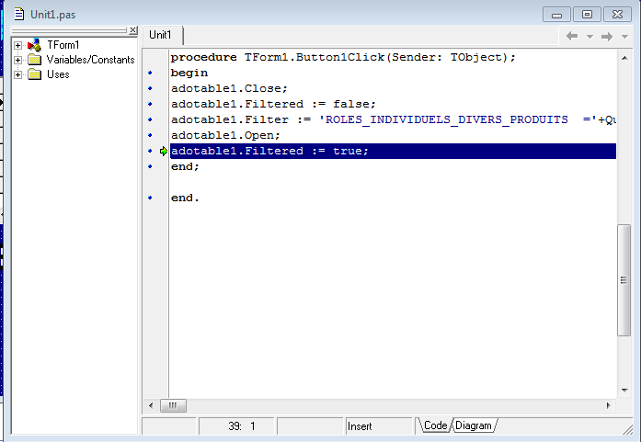
unit Unit1;

interface

uses
Windows, Messages, SysUtils, Variants, Classes, Graphics, Controls, Forms,
Dialogs, StdCtrls, DB, Grids, DBGrids, ADODB;

type
TForm1 = class(TForm)
DBGrid1: TDBGrid;
Button1: TButton;
Edit1: TEdit;
Button2: TButton;
Label1: TLabel;
ADOConnection1: TADOConnection;
ADOTable1: TADOTable;
DataSource1: TDataSource;
procedure Button1Click(Sender: TObject)
private
}Private declarations {
public
}Private declarations {
end;

var
Form1: TForm1;

implementation

{$R *.dfm}

procedure TForm1.Button1Click(Sender: TObject);)
begin
adotable1.Close;
adotable1.Filtered := false;
adotable1.Filter := 'ROLES_INDIVIDUELS_DIVERS_PRODUITS ='+QuotedStr(edit1.text;)
adotable1.Open;
adotable1.Filtered := true;
end;

end.

